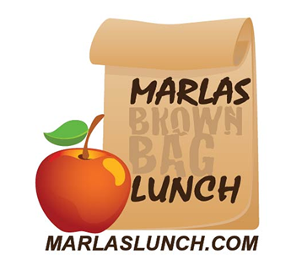
Welcome to Marla’s
Lunch at a Glance
A quick peek INTO CROW ISLAND’S
Lunch Program 2017/2018

Please check the website for a full menu

Online Ordering begins 8/14/2017
First Day of Lunch Wednesday, 8/30/2017

Monday | Tuesday | Wednesday | Thursday | Friday
Grill Day  Grill it Up!  Hormone free Antibiotic Free tenders  grilled chicken sandwiches,  Salads,  all beef burgers,  baked potato bar & more  served with  seasonal fresh fruit, cut cucumbers with ranch,  and pretzel sticks  ala carte sprinkle cookie  Organic milk, Chocolate milk and Naked Juice available daily | Pizza Day  It’s Pizza Day w/Piero’s & Viccino’s!  Homemade personal pan pizzas, pasta with homemade dairy free sauce, salads & more  Served with Fresh sliced fruit and cut carrots with ranch  and cookies  Organic milk, Organic lowfat Chocolate milk, Naked Juice available daily | Brunch/Deli Day  Brunch at School  Breakfast into lunch:  Multi grain pancakes, french toast, oatmeal, breakfast sandwiches homemade soups, & all natural sliced turkey & more  Served with organic yogurt and organic bananas  Deli & Soup Cafe  Homemade Soups, & all natural sliced turkey, Bagels, grilled sandwiches & more  Organic milk, Chocolate milk and Naked Juice available daily | Sandwich Shop  Potbelly  Gourmet Sub Sandwiches, soups and salads  Panera Bakery Cafe  Clean eating café with soups, salads, sandwiches, & more  Subway  Classic deli subs on fresh baked bread  Organic milk, Chocolate milk and Naked Juice available daily | Special Lunch “Around The World”  Lil’ Italy  Homemade Pastas Sauces, Sandwiches & More!  Uno Dos Tres-It’s  Authentic Mexican  Deconstructed! served with homemade chips & salsa  Little Italy  Homemade Pastas Sauces, Sandwiches & More!  Last Friday of every month is around the world!  Avli-Mediterranean  Penny’s -Thai Asian  Freshii-Simply Fresh!

