Announcing Crow Island
4th Grade Book Club

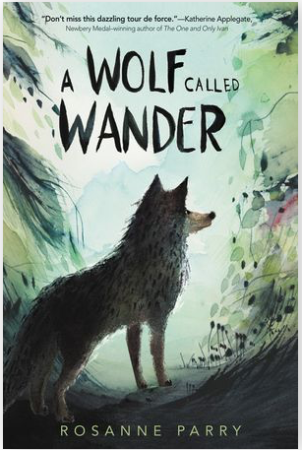

Swift, a young wolf cub, lives with his pack in the mountains learning to hunt, competing with his brothers and sisters for hierarchy, and watching over a new litter of cubs. Then a rival pack attacks, and Swift and his family scatter. Alone and scared, Swift must flee and find a new home. His journey takes him a remarkable 1000 miles across the Pacific Northwest. The trip is full of peril, and Swift encounters forest fires, hunters, highways, and hunger before he finds his new home. – Junior Library Guild Summary

Please join us for a wonderful journey of friendship and perseverance as part of a Crow Island tradition.
When: Tuesdays at Lunch (after recess)
Dates: 2/11/2020 – 3/10/2020
Where: Mr. Dugo’s Classroom
Bring: Nut-free lunch or hot lunch and your own copy of the book; please read to the end of the Fight chapter (p 44) before the first session
Sign up: Please return the attached permission slip signed by both parent and student as soon as possible and not later than Wednesday, February 5, 2020. We will accommodate as many students as possible, but may need to cap participation if there is very high interest.

